# Career Episode 1

# 1.1 Introduction

|  |  |
| --- | --- |
| Title | Installation and Commissioning of Vacuum Booster Pump |
| Location | Bhikki, District Sheikhupura Punjab Pakistan |
| Position | Performance Analyst |
| Organization | General Electric International Inc. (GEII) (GE Power) |
| Chronology | Sep 2018 – April 2019 |

# 1.2 Background

## 1.2.1

The Halmore Power Plant is privately owned by the Halmore Group, operating as an Independent Power Producer (IPP) in the Punjab province of Pakistan. GEII (General Electric International Inc.) is the O&M contractor and is responsible for safe and reliable operation of the plant according to industry prudent practices. Additionally, GE fulfills its contractual commitments, including the Power Purchase Agreement (PPA) obligations. Collaborating with the Regional Control Center (RCC) ensures efficient power distribution. The regulatory body overseeing electricity supply in Pakistan is National Electric Power Regulatory Authority (NEPRA), which issue licenses for electricity generation, transmission, and distribution. NEPRA's role extends to the establishment and enforcement of standards that guarantee the quality and safety of electric power operation and supply to consumers.

The complex consists of two Gas Turbines (GE PG6111FA), two Heat Recovery Steam Generators (HRSGs), a single Steam Turbine and apporpriate Balance of Plant equipment. The gas turbines have the ability to operation on both gas fuel (primary fuel) and liquid fuel (Backup fuel). The minimum continuous operating level of plant is 25% of the base load. As the complex is combined cycle power plant so gas turbines are connected to HRSGs which generate and supply steam to double pressure ( HP & LP) condensing type steam turbine.

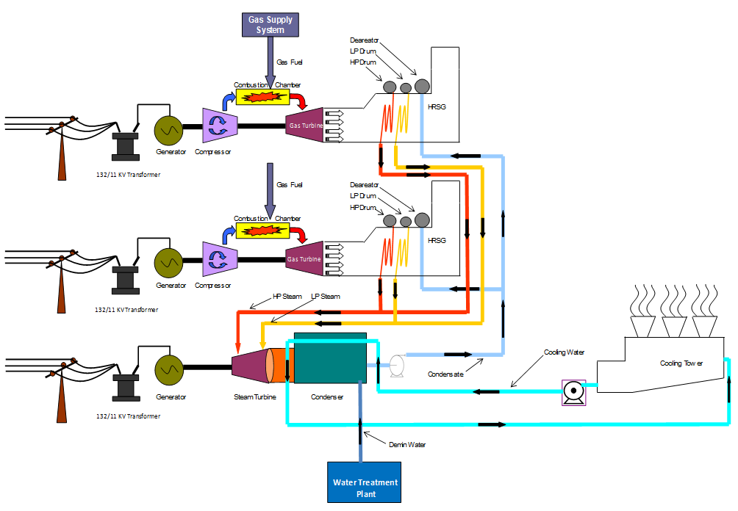

Figure 1: Plant Layout

In 2016 GE and Owner signed a new contract Predictability Enhancement and Performance Improvement (PEPI) for performance improvement of plant, aimed at enhancing the plant's performance through deployment of diverse solutions. Within the framework of this contract, GE undertakes the responsibility of conducting a comprehensive performance analysis of the power plant. Upon obtaining approval from the Owner, GE proceeds to implement solutions designed to improve plant performance. Importantly, GE would be responsible for funding the expenses associated with these solutions and, subsequently, sharing the cost savings generated from reduced fuel consumption in the energy payment structure with the Owner. This setup enables GE to generate additional profits once the initial investment is recuperated. As an additional responsibility I am also responsible for the P&L of PEPI contract.

## 1.2.2 Objective

Since the commissioning, the steam surface condenser installed at Halmore Power Plant has been facing issues with air ingress. The air flow at the main vacuum pump outlet consistently exceeded design limits, leading to reduced vacuum levels and decreased steam turbine output.

## 1.2.3 Main Technical Data

The steam surface condenser unit, manufactured by Greens Power Limited, was expertly installed and commissioned by Descon Pakistan, the primary Engineering, Procurement, and Construction (EPC) contractor for the project. Meanwhile, the main vacuum pumps were sourced from Premier Fluids, Canada. This steam surface condenser unit features a single-shell design, incorporating a double-pass configuration with divided water boxes. Its orientation is horizontal, and it functions as a surface-type condenser. The process involves the passage of steam from the exhaust of the low-pressure turbine, moving through the shell transition and enveloping the tube bundle. Within this bundle, the steam undergoes condensation, descending to the bundle's lower region and eventually collecting in the hotwell. The condenser air removal vacuum pumps are self-contained systems, utilizing water-sealed liquid ring vacuum pumps. These units efficiently manage the removal of air from the condenser, contributing to its optimal performance.

# 1.2.4 Nominal Parameters

**Design Conditions**

|  |  |  |  |
| --- | --- | --- | --- |
| Shell Side | | Tube Side | |
| Total Duty | 155.26 MW | Source of water: | Cooling Tower |
| Steam Inlet | 260,000 kg/h | Cooling Water Flow | 15588 m3/h |
| Non-Condensable | 25.49 kg/h | Temp Water In | 26.4 °C |
| U-Service | 2.84 W/m2 K | Temp Water Out | 35.0 °C |
| Saturation Temp | 41.53 °C | Number of Passes | 2 |
| Condenser Temp | 41.53 °C | Water Velocity | 2.2m/s |
| LMTD | 10.24 °C | Pressure Drop | 0.46 bar |
| Operating Pressure | 0.08 bar abs | Cleanliness Factor | 85% |
| Surface Area | 5407 m2 | Specific Heat | 41668 KJ/kg K |

Table 1: Steam Surface Condenser Technical Data

# 1.2.4 Project Overview

After considering various potential solutions to address the problem of air ingress in the steam surface condenser, I proposed as solution of adding a vacuum booster pump to the existing vacuum pump to eliminate non-condensable gases. The implementation spanned phases:

* technical proposal.
* solution selection.
* Implementation.
* post-implementation performance testing.

# 1.2.4 Organizational chart

Figure 2: Hierarchy

# 1.2.5 Duties Make only max 12 points

* Conducting a Root Cause Analysis (RCA) of the poor condenser vacuum.
* Collecting condenser, main vacuum pumps, and steam turbine design and historical operational data and comparing it with historical trends, especially with the Commercial Date of Operation (COD).
* Contacting the Original Equipment Manufacturer (OEM) of the installed vacuum pumps and discussing the problem while asking for an appropriate solution.
* Ordering the vacuum booster pump and arranging the required P.O.
* Preparing the scope of work and selecting a vendor for the installation while understanding the requirements of different stakeholders (Operations and Maintenance).
* Reviewing the Basic Engineering Design (BED) and Detailed Engineering Design (DED) received from the contractor.
* Review of the P & ID, piping plans and isometrics keeping in view the integration of new piping with the existing plant piping network
* Commissioning of the new Booster Pump, including the DVD2 panel and VFD, in-house.
* Implementation of logic interlocks with the existing system to ensure the reliable operation of the existing and newly installed system.
* Developing quality hold point documents and carrying out quality checks during the implementation phase for installation.
* Ensuring the safety of the plant, equipment, and personnel as a top priority.
* To deal with the problem that appeared on the site.

# 1.3 Personal Engineering Activity

# 1.3.1

In the project as a “Performance Analyst/ Project Manager” I was responsible for reviewing all the design and technical data provided by the OEM of Steam Surface Condenser (Greens Energy Limited), Steam Turbine (Nova Pignone) and Main Vacuum Pumps (Premier Fluids) along with plant operational data both current and historical to ascertain the technical. Them main objective was to analyze the cause of poor Condenser Vacuum from the following.

* Poor heat exchange in condenser
* Poor cooling tower performance
* ST higher exhaust energy
* Air Ingress

I even collaborated with the operations team on different operational schemes by increase and decreasing the flow of cooling water towards the steam surface condenser to investigate the exact root cause.

|  |  |
| --- | --- |
| 8 CT Fans & 3 CW Pumps | 8 CT Fans & 4 CW Pumps |
| CW in 19.5 °C | CW in 22.2 °C |
| CW out 28.2 °C | CW out 29.28 °C |
| Condenser Vacuum -0.91 Bar | Condenser Vacuum -0.92 Bar |
| Condenser Temperature 41.8 °C | Condenser Temperature 40.9 °C |
| TTD 14.3 | TTD 15.9 |
| Sub Cooling 3.8 | Sub Cooling 4.2 |
| ST Output 70 MW | ST Output 69.12 MW |

Table 2: Comparison of Operational Data

From above data with the addition of cooling water pump the Terminal Temperature Difference (TTD) and sub cooling increases which in turn means that their air ingress. I also investigated in collaboration with the operations team to check for any points of air ingress but since it was design/ inherent issue so there were no conclusive results. Even the calculate thermal duty by heat balance calculation indicated that it should be 98.1 % or 152MW whereas it was more than 120 %. Thermal load increase was because of air ingress.

# 1.3.2

I contact Premier Fluids, the original equipment manufacturer (OEM) of the main vacuum pumps, in search of an additional booster pump compatible with the existing system. The OEM's design team thoroughly assesses the capability of the vacuum pumps, already installed system, and recommends the utilization of their MODEL 1083HV vacuum booster unit. This proposed solution encompasses the following key components:

1. An 18.5KW electric motor, TEFC, rated at 400V-3ph-50hz and operating at 1500 rpm.
2. A Starter-Control Panel Enclosure, inclusive of:

* An 18.5KW Variable Frequency Drive Unit.
* A PFS Model Hydrotwin DVD2 process controller.
* Inlet and outlet pressure transducers.
* A 6” NPS Inlet Butterfly valve.
* A 3/4” size Flushing Solenoid valve (SOL-2) equipped with an inlet filter.
* A fabricated Steel skid frame designed for mounting the equipment and components.

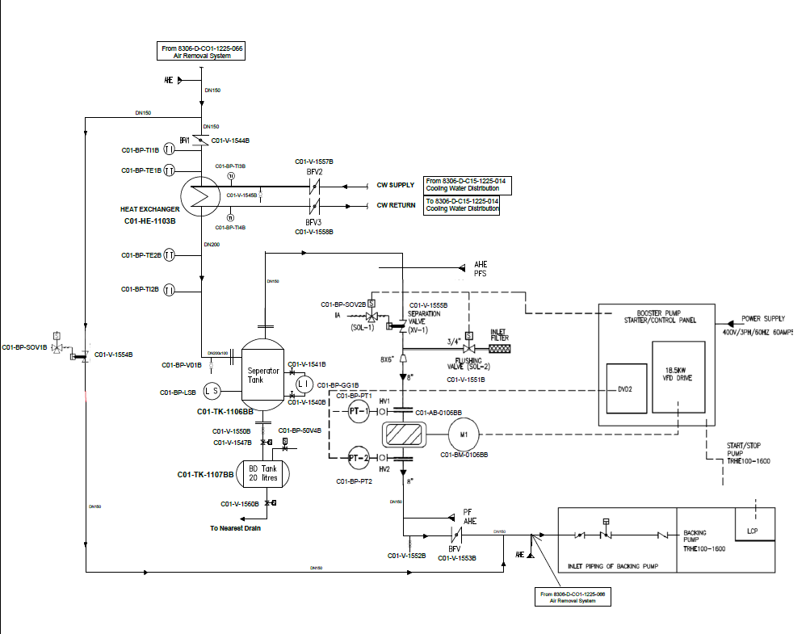

Figure 3: P&ID of Vacuum Booster Pump.

Following an extensive evaluation of the supplier's booster pump data and performance capability curve, it was confirmed that the pump is indeed compatible with the existing system and can effectively enhance the vacuum. Considering our calculations, particularly in light of the PEPI contract's expiration in 7 years, we projected a Return on Investment (ROI) of less than 1.5 years with a 50% service factor. This was accompanied by a positive Net Present Value (NPV). I also compiled a formal technical proposal that took into account all available data. This proposal received approval from both the Program Manager and the Owner.

# 1.3.3

After receiving approval, I submitted a purchase request (PR) to the procurement department to initiate the ordering of the pump from Canada, considering a lead time of 3 months. Once the pump arrived in January 2019, I meticulously formulated a comprehensive Scope of Work (SOW) for the vendor, outlining the installation and commissioning procedures while ensuring the utmost focus on quality and safety. I also collaborated with the site's mechanical engineer to incorporate ASME 31.1 standards for the steam piping, guaranteeing the work's quality. By engaging the chosen vendor, along with the project manager and project coordinators, I finalized both the Basic Engineering Design (BED) and Detailed Engineering Design (DED). Moreover, P & ID, piping plans and isometrics were also reviewed and finalized keeping in view the integration of new piping with the existing plant piping network.

I devised a performance testing procedure for both before and after the installation of the vacuum booster pump. To structure these procedures, I referenced the guidelines outlined in ASME PTC 12.2 Performance Testing Code (1998) for Steam Surface Condensers and ASME 6.2 for Steam Turbines in Combined Cycle (2004). Furthermore, I incorporated the correction curves provided by the OEMs for the steam turbine and steam condenser to accurately assess and compare the steam turbine's output. The instrumentation at the station used for conducting the tests adhered to the requirements set out in the relevant codes. To ensure precision, we took additional steps such as recalibration and meticulous recording of any deviations.

# 1.3.4

I actively participated in on-site testing and confirmed the calibration of pivotal station instruments. The precision of these instruments directly influenced the accuracy of the test outcomes. Throughout this engagement, my focus remained on guaranteeing full compliance with site safety protocols among all involved personnel. Every detail of permit-to-work (PTW) documentation was diligently verified, and an unwavering commitment to the utilization of personal protective equipment (PPE) was consistently enforced.

Notably, the calibration procedure revealed no significant deviations in measurements. The subsequent list presents a representative selection of instruments subjected to scrutiny as integral components of the comprehensive test readiness assessment:

|  |  |
| --- | --- |
| **Sr. No** | **Description** |
| 1 | Ambient Temperature |
| 2 | Ambient Pressure |
| 3 | Relative Humidity |
| 4 | Surface Condenser Vacuum |
| 5 | ST Exhaust Temperature |
| 6 | ST Exhaust Pressure |
| 7 | Cooling Water In and Out Temp |
| 8 | Cooling Water In and Out Pressure |
| 9 | Cooling Water Flow |
| 10 | HP Steam Flow Meter at HRSG |
| 11 | LP steam Flow Meter at HRSG |
| 12 | HP steam flow meter at Turbine Inlet |
| 13 | LP steam flow meter at Turbine Inlet |
| 14 | Steam Turbine Exhaust Pressure |
| 15 | Main Vacuum Pump Flow meters |

Table 3: List of Instrumentation

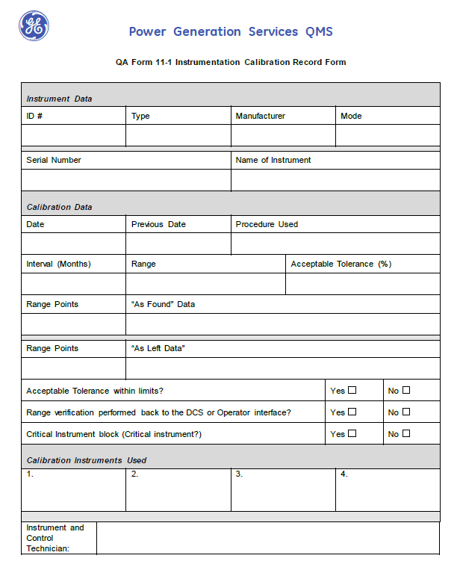

Figure 4: Field Calibration Certificate

# 1.3.5

Another significant factor that significantly influenced the accuracy of the test results was cycle isolation. In response, I created a comprehensive checklist for site cycle isolation, ensuring that no deviations occurred between the "before" and "after" tests. I also took measures to guarantee the uniformity of ambient and process parameters. To confirm the effectiveness of isolation, I conducted on-site inspections and drain tests. In cases where downstream drains were absent, I utilized temperature guns to validate the passage of fluid. By considering all these factors, I established a baseline for accurate comparison.

# 1.3.6

After completion of the project, I developed an operating procedure for the new vacuum booster pump keep in view the operational safety of the existing system, implemented interlocks by site and site HSE requirement. The operating procedure underwent validation from key stakeholders, including the Lead Operations Engineer, Safety Officer, and Program Manager. Furthermore, this operating procedure served as a valuable resource for the team, aiding in their familiarity with the new system, its operational considerations and safety interlocks.

# 1.4 Problems and solutions

# 1.4.1

The primary aim of the vacuum booster pump was to enhance the vacuum by removing non-condensable gases from the steam surface condenser. During the Basic Engineering Design (BED) phase, it was determined that the vacuum booster pump would operate in a slave mode alongside the main vacuum pump. However, the configuration provided by OEM panel contradicted this arrangement. In response, I collaborated with the site's electrical team to introduce an additional panel, which rectified the configuration. This additional panel ensured that the vacuum booster pump functioned as the slave thus getting feedback from main vacuum pump for its operation. It also included enhanced protection measures, such as checking the status of the main vacuum pump and requiring the vacuum level to exceed -850Mbar before the vacuum booster pump could come into service. Additionally, in cases of a vacuum loss in the main system (below -800Mbar), a master override protection was implemented to halt the vacuum booster pump.

# 1.4.2

After evaluating the capability curve of the booster pump, it became evident that the pump's design was tailored for lower inlet temperatures than those of extraction, which was overlooked by both Premier Fluids and site team. This disparity negatively impacted the system's efficiency, preventing it from operating at its maximum capacity. After engaging in thorough discussions with both the OEM and the Program Manager regarding this issue., I suggested the installation of a heat exchanger at the suction point of the booster pump to lower the temperature. Additionally, a moisture separator tank would be integrated to extract excess moisture from the suction.

To ensure the successful integration of these adjustments, the Scope of Work (SOW) for the vendor, which focused on installing the vacuum booster pump, underwent a revision. To preempt any potential issues, I conducted a thorough inspection of the heat exchanger's design to ensure its compatibility and efficiency.

# 1.4.3

The primary role of the moisture separator tank was to separate excess moisture from the non-condensable gases, thereby lessening the moisture load on both the vacuum booster pump and the main vacuum pump. The accumulated moisture or water was intended to be discharged into a water drain. To facilitate this process, an additional small blow down tank was introduced between the main collector tank and the drain. This was done to prevent atmospheric air from entering the vacuum system while the draining occurred. For this purpose, a sequence of valves was implemented. These valves enabled the system to be isolated from atmospheric air during the draining phase and subsequently reconnected after the draining process was completed.

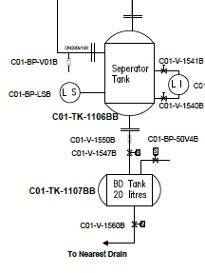

Figure 5: Blow Down Tank

During the draining process, the solenoid-operated valve CO1-V-1547B will close, while the drain and vacuum breaker solenoid-operated valve, CO1-V-1560B and CO1-V-50V4B, would open. To restore the system, the drain and vacuum breaker valve would close, and the inlet would open. This sequence is automatically governed by a Level Switch.

During the reconnection of the blow down tank with the separator tank, an influx of air replaced the water, which subsequently rushed into the system. This air influx caused the vacuum booster pump's VFD to trip due to overload protection. As the VFD and interlock were under site scope. I addressed this issue by collaborating with the OEM and updating the VFD settings to accommodate this air inflow during reconnection, thereby enhancing the booster pump's operational longevity.

# 1.5 Creative works

During the implementation phase, I also recommended the incorporation of an HMI on the additional panel to record alarm history, addressing a feature lacking in the OEM panel. This would help in trouble shooting the system in case of failure. In consideration of the vacuum booster pump's intended series operation with the main vacuum pump, the installation of a bypass valve was suggested. This valve would facilitate the operation of main vacuum pump in establishing the initial vacuum according to predefined interlock parameters. Additionally, adjustments were made to the configuration of the inlet and bypass valves, aimed at enhancing the overall safety of the system's operation. The bypass, inlet and isolation valves also helped in maintenance of the vacuum booster pump while keeping the system in service.

# 1.6 Project management

This project was marked by its complexity, involving tasks such as liaising with the OEM to acquire essential information, cross-referencing specifications against relevant codes and standards, and coordinating with operational shift staff to execute baseline testing. The acquisition of operational data through high-speed trend analysis, the generation of activity reports, and the recording of test results were all part of the process.

As the project lead, I held the responsibility of orchestrating all necessary resources, organizing safety documentation for field activities, and coordinating with stakeholders. I ensured the attainment of required approvals from the site safety representative and made certain that all working parties adhered to GE's site-specific protocols. Concurrently, I monitored the project timeline closely, considering that the initial T-off points of the booster pumps were fabricated during the first available shutdown opportunity. Subsequently, the remaining equipment was installed even when the plant was in operation so as the work could be completed in defined time line.

# 1.7 Codes

Throughout the project's duration, we adhered to the guidelines outlined by prominent industry standards. The ASME Code 31.1 for steam piping, ASME PTC 12.2 Performance Testing Code (1998) for Steam Surface Condensers, and ASME 6.2 Steam Turbine in Combined Cycle (2004) were pivotal references that shaped our approach. These established standards played a crucial role in steering us through the testing and implementation phases, providing a solid framework that helped us navigate potential pitfalls and challenges effectively.

# 1.8 Summary

This project made a substantial impact by contributing to the reduction of complex heat rate through the elevation of the steam surface condenser vacuum, achieved by the removal of non-condensable gases. This innovation enabled us to attain a higher steam turbine output without introducing any additional energy input. This accomplishment led to tangible financial gains for both the customer and GE. The introduction of the vacuum booster pump played a pivotal role in augmenting the air extraction system's capabilities, leading to an enhancement of the condenser vacuum by 0.02 Barg. Moreover, by utilizing the OEM Steam Turbine output correction curve, the installation of the vacuum booster pump correlated with an estimated output increase ranging from 600 to 800 Kwh. Notably, this enhancement was not only theoretical but also substantiated by actual data, resulting in a noteworthy heat rate improvement of 0.35%.

Engaging within cross-functional project teams pushed me to step out of my comfort zone, enabling me to acquire new skills like conducting/ reviewing field testing, results documentation, designing testing procedures, and operational guidelines. This experience proved to be an exceptional learning opportunity, one that enriched my professional growth.